Contents

ArcGIS Velocity gRPC 2

Key Velocity gRPC feed type concepts 2

Usage notes 4

Server Implementation 4

Creating a feed using the user interface 4

Creating a feed using the swagger API 6

Client Implementation 11

Creating the boilerplate code 11

Sending data 11

Response send(Request) 11

void send(Request, StreamObserver) 11

StreamObserver Stream(StreamObserver) 12

Flow Control 12

Feature Wrapper 12

gRPC Response Codes 12

Appendix 15

Host name 15

Swagger API 15

# ArcGIS Velocity gRPC

The gRPC feed type in ArcGIS Velocity creates a built in gRPC server endpoint that can be used to programmatically send data from a remote gRPC client application to Velocity with gRPC requests. Client applications can be developed in a variety of languages, as supported by the gRPC framework at <https://grpc.io/>. Utilizing the tools provided by the gRPC framework, the underlying communication stub objects required to communicate with Velocity are generated automatically. Developers are left to create the custom client application around the provided stubs.

## Key Velocity gRPC feed type concepts

The Velocity gRPC feed type is built around several key concepts that must be understood before developing a custom gRPC client for ArcGIS Velocity. Fundamentally, the gRPC feed type implements the standard requests/response remote procedure call defined by the gRPC framework. The details on how the standard communications have been implemented are presented below:

* Feature:
  + The Feature is synonymous with an event. It represents a single message to be sent to Velocity.
  + A Feature is defined as an array of Any values. Each data type (string, integer, long, float, double, Boolean, …) has a translation method to convert it to the Any type.
  + The order of the Feature’s value array represents the pre-determined schema that is registered with the gRPC feed. In other words, when creating a Feature object, the order the values are added must match the schema the Velocity gRPC feed is expecting.
  + The client message is typically wrapped with an adapter that will translate the client message into a Feature object. This ensures the client messages are properly translated into the event schema expected by the Velocity gRPC feed.
* Request:
  + The Request contains an array of one or more Features.
  + The Request is typically used as is.
* Response:
  + The Response contains a response code (like HTTP response codes) and a response message. The code and the message can be used to determine if the request (or stream of requests) was received successfully or if an error occurred.
  + A Response is returned as a result of each send() procedure call (one request, one response).
  + A Response is returned when a stream() procedure call is closed (many requests, one response).
  + The Response is typically used as is.
* Channel:
  + The Channel represents a communication channel that is opened between a client application and the Velocity gRPC feed.
  + Channels must always utilize transport security (ssl).
  + A Channel is created by providing a host name and a port.
    - Host name is a public fully qualified domain name of the hosting server. It is provided on the Velocity gRPC feed details page.
    - Port will always be 443.
  + Channels are augmented with Metadata (see below) to assist with communication header values.
* Metadata:
  + The Metadata represents the underlying header values used when creating the Channel.
  + Feed path (required):
    - The header key ‘grpc-path’ is required and must be set.
    - The header value for the ‘grpc-path’ is the Velocity gRPC feed path provided on the feed’s details page.
  + Token authorization (optional):
    - The header key ‘authorization’ can be provided if the Velocity gRPC feed has bee created using ArcGIS authentication.
    - The header value, if set, will be ‘Bearer <token>’
    - The token value is obtained from the sharing interface of the ArcGIS Online organization that is hosting Velocity.

https://<hostserver>.arcgis.com/sharing/rest/generateToken

* Feed Stubs:
  + The Feed Stubs decorate the underlying communications and present the standard methods for sending requests and receiving responses.
  + Feed Stubs are created by passing in the channel and metadata information to the factory methods provided by the underlying framework.
  + Methods:
    - Send:
      * A blocking RPC call to the server. The method sends a single Request and waits for a Response.
    - Stream:
      * A non-blocking call to open a channel to the server.
      * A stream observer is used to pass Requests to the open stream.
      * The server will not send a Response for each individual Request.
      * When a stream is closed, the server will send a single Response for the entire stream session.
* StreamObserver:
  + The Stream Observer is responsible for managing an open stream. It provides methods for sending requests, managing responses, and closing the stream. There are multiple implementations of the Stream Observer, depending on your needs.
    - Pass in a Response StreamObserver to the send() method to asynchronously process the response.
    - Pass in a Response StreamObserver to the stream() method to asynchronously monitor a streaming feed.
    - StreamObserver is returned from the stream() method to allow sending of Requests via the onNext() method.
  + Methods:
    - OnNext:
      * Passes the Request to the underlying channel to be sent to the server.
      * Receives sigle asynchronous Response for stream() when stream is closed.
      * Receives asynchronous Response for send().
    - OnCompleted:
      * Closes the stream.
    - OnError:
      * Indicates an error was encountered on the underlying channel.

## Usage notes

* The Channel must always use Transport Security (ssl).
* The Metadata must always include the header key ‘grpc-path’ with the value set to the path provided on the Velocity gRPC feed details page.
* When using ArcGIS security, the Metadata should include the header key ‘authorization’ with the value set to the token obtained from the ArcGIS Online organization’s */sharing/rest/generateToken* end point.
* The Response code may be either the standard HTTP response codes (e.g. 200 for success) or those reported by the gRPC api (see table below).

**EXAMPLE:** If a Velocity gRPC feed is stopped or the “grpc-path” is not set correctly, the following error will be observed:

io.grpc.StatusRuntimeException: UNIMPLEMENTED: HTTP status code 404

# Server Implementation

## Creating a feed using the user interface

1. Press the ***Create feed*** button and select the ***Web and Messaging group***.

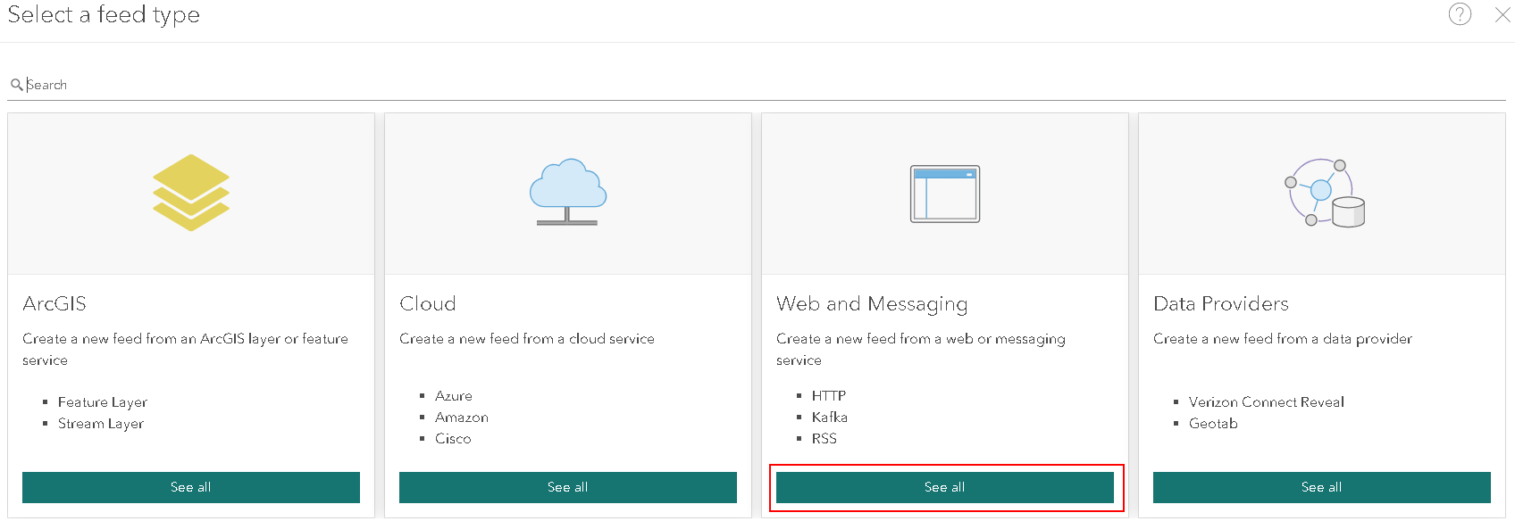

1. Select the gRPC type

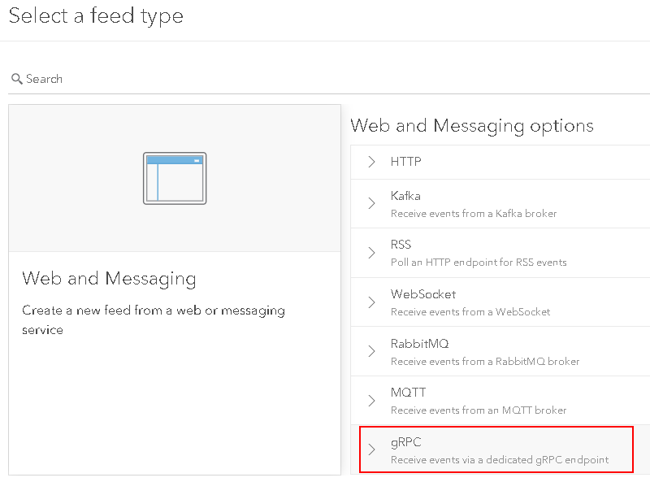

1. Chose the authentication type
   1. None – No authentication is required to send data to the feed. Not recommended.
   2. ArcGIS – Provides token base authentication. Currently, tokens are obtained by the client application using a user’s credentials. The user must have access to Velocity and be a ‘creator’ user.
2. Add the data schema
   1. Select the format of your data sample:
      1. Delimited – comma, tab, or otherwise separated fields.
      2. JSON
      3. XML
   2. Paste your data sample into the text field
      1. Use the *Format* and *Word Wrap* buttons  to modify how the data sample is displayed.

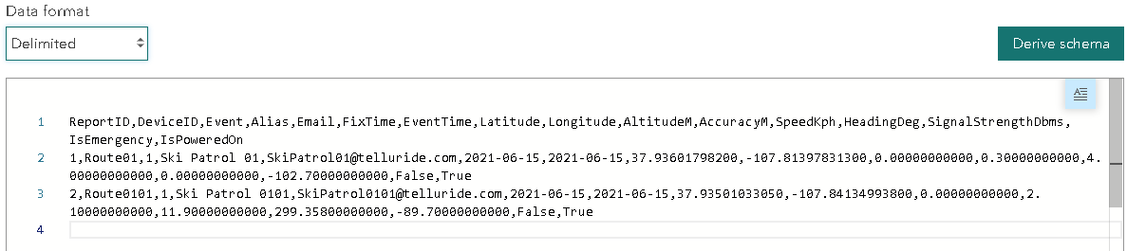

* 1. Press the *Derive Schema* button to generate the data schema

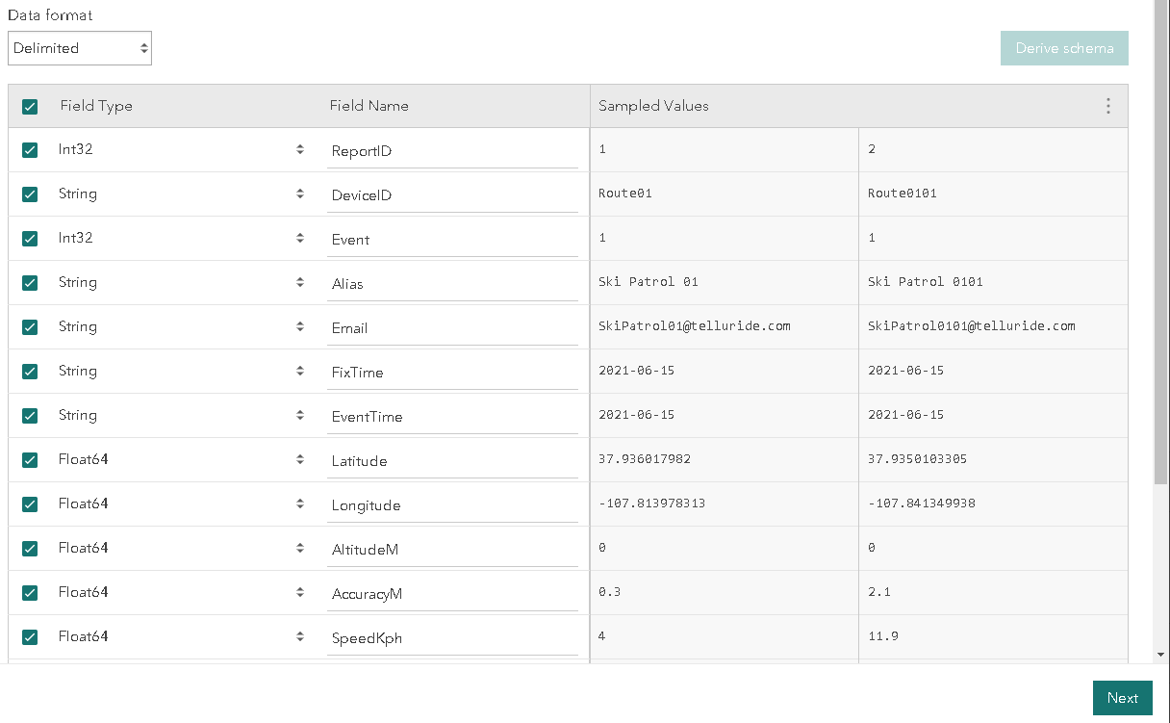

* 1. Modify the field names and/or turn fields on/off then press the *Next* button.
  2. Select your Location, Time, and Track ID fields. Press the *Next* button.
  3. Finally, add a name and description for your feed. Press the *Complete* button to create the feed.

1. On the resulting feed details page, you can review the new feed’s properties. Of these, a few are important for the gRPC client application development.
   1. gRPC endpoint header path – Use the value of this property in your gRPC client to identify the feed your client is trying to communicate with.
   2. gRPC endpoint URL – Use this as the server host name your gRPC client will connect to.
   3. Schema details – The list of fields, their types, and the order they are expected. Your gRPC client application is required to match this structure exactly when sending Features to the Velocity gRPC feed.

## Creating a feed using the swagger API

Below is the JSON format for creating a new Velocity gRPC feed type. On the Velocity swagger API page, locate the Feed section and expand the *POST/iot/feed/ Creates a new feed instance* item. Paste your updated JSON into the space provided and press the Execute button. Navigating back to the Velocity application, the new feed’s details page should be available. See above for a description of the important properties.

{

"id": "",

"label": "Factal gRPC",

"description": "A feed to receive Factal gRPC events",

"feed": {

"name": "grpc",

"formatName": "grpc-feature",

"schemaTransformation": {

"inputSchema": {

"attributes": [

{

"name": "id",

"dataType": "Int64",

"nullable": true,

"tags": [

"TRACK_ID"

]

},

{

"name": "severity",

"dataType": "Int64",

"nullable": true,

"tags": []

},

{

"name": "factal_url",

"dataType": "String",

"nullable": true,

"tags": []

},

{

"name": "source_url",

"dataType": "String",

"nullable": true,

"tags": []

},

{

"name": "content",

"dataType": "String",

"nullable": true,

"tags": []

},

{

"name": "created_date",

"dataType": "String",

"nullable": true,

"tags": []

},

{

"name": "updated_date",

"dataType": "Date",

"nullable": true,

"tags": [

"START_TIME"

]

},

{

"name": "arc_id",

"dataType": "Int64",

"nullable": true,

"tags": []

},

{

"name": "arc_name",

"dataType": "String",

"nullable": true,

"tags": []

},

{

"name": "latitude",

"dataType": "Float64",

"nullable": true,

"tags": []

},

{

"name": "longitude",

"dataType": "Float64",

"nullable": true,

"tags": []

},

{

"name": "location_name",

"dataType": "String",

"nullable": true,

"tags": []

},

{

"name": "location_type",

"dataType": "String",

"nullable": true,

"tags": []

},

{

"name": "regions",

"dataType": "String",

"nullable": true,

"tags": []

},

{

"name": "tags",

"dataType": "String",

"nullable": true,

"tags": []

},

{

"name": "verticals",

"dataType": "String",

"nullable": true,

"tags": []

}

],

"geometry": {

"geometryType": "esriGeometryPoint",

"spatialReference": {

"wkid": 4326

},

"hasZ": false,

"hasM": false

},

"time": {

"timeType": "instant"

}

},

"fieldMappings": [

{

"fromField": "id",

"toField": "id",

"tags": [

"TRACK_ID"

]

},

{

"fromField": "severity",

"toField": "severity",

"tags": []

},

{

"fromField": "factal_url",

"toField": "factal_url",

"tags": []

},

{

"fromField": "source_url",

"toField": "source_url",

"tags": []

},

{

"fromField": "content",

"toField": "content",

"tags": []

},

{

"fromField": "created_date",

"toField": "created_date",

"tags": []

},

{

"fromField": "updated_date",

"toField": "updated_date",

"tags": [

"START_TIME"

]

},

{

"fromField": "arc_id",

"toField": "arc_id",

"tags": []

},

{

"fromField": "arc_name",

"toField": "arc_name",

"tags": []

},

{

"fromField": "latitude",

"toField": "latitude",

"tags": []

},

{

"fromField": "longitude",

"toField": "longitude",

"tags": []

},

{

"fromField": "location_name",

"toField": "location_name",

"tags": []

},

{

"fromField": "location_type",

"toField": "location_type",

"tags": []

},

{

"fromField": "regions",

"toField": "regions",

"tags": []

},

{

"fromField": "tags",

"toField": "tags",

"tags": []

},

{

"fromField": "verticals",

"toField": "verticals",

"tags": []

}

]

},

"properties": {

"grpc-feature.yField": "latitude",

"grpc-feature.xField": "longitude",

"grpc-feature.dateFormat": "yyyy-MM-dd'T'HH:mm:ss.SSS'Z'",

"grpc-feature.buildGeometryFromFields": true,

"grpc.authenticationType": "none"

}

},

"properties": {

"executable": true

},

"status": {

"startTime": 1625853385613

}

}

# Client Implementation

## Creating the boilerplate code

The client will require a number of boilerplate code to establish the gRPC objects. Each language is a bit different in how this is accomplished, but the pattern is generally the same: Using the *grpc_feed.proto* file below, a tool provided by the gRPC API is run to generate the code.

<https://grpc.io/docs/languages/>

*grpc_feed.proto* File:

syntax = "proto3";

import "google/protobuf/any.proto";

option java_multiple_files = true;

option java_package = "com.esri.realtime.core.grpc";

option java_outer_classname = "GrpcProto";

service GrpcFeed {

// client streaming rpc for high velocity

rpc stream(stream Request) returns (Response);

// simple rpc for lower velocity

rpc send(Request) returns (Response);

}

// main api methods

message Request {

repeated Feature features = 1;

}

message Feature {

repeated google.protobuf.Any attributes = 1;

}

message Response {

string message = 1;

int32 code = 2;

}

## Sending data

### Response send(Request)

The Synchronous / Blocking request *send(Request)* will send a single Request object, containing one or more Features, and block the calling thread until a response is returned. Use this method when a response from the server is required for every request and processing the response is required before the next Request is sent. This may be useful in situations where a queue of Features is maintained, and each Feature is removed from the queue upon successful Response. This method is not recommended for higher velocity data feeds.

### void send(Request, StreamObserver)

The Asynchronous / non-Blocking request *send(Request, StreamObserver)* will send a single Request object, containing one or more Features, and return immediately. The passed in StreamObserver object can be used to process the Response. A single Response will be returned by the server for every Request. Use this method when a response from the server is desired for every request but processing the response is not required before the next Request is sent. This method is not recommended for higher velocity data feeds.

### StreamObserver Stream(StreamObserver)

The Asynchronous / non-Blocking request *stream(StreamObserver)* will open a stream to send multiple Request objects, each containing one or more Features. Sending a request will not result in a Response from the server. The returned “request” StreamObserver can be used to send individual requests using the *onNext(Request)* method and close the stream using the onCompleted() method. The *stream()* method is recommended for medium velocity data feeds.

The passed in “response” StreamObserver object can be used to monitor for errors in the underlying channel, process the final Response object, and verify the stream is closed. A single Response will be returned by the server when the stream is closed (no other response will be sent). Use this method when a response from the server is not needed for every request.

When using the stream() method, care should be taken on the client side to allow the server some time to process Requests. Unfortunately, at the moment, there is no strong guideline in predicting the server’s capacity or overload thresholds.

## Flow Control

gRPC supports the concept of “flow control.” This technical capability adds an additional communication channel between the client and server allowing the two applications to report their capacity to process data. If the Velocity gRPC server is overloaded, it will communicate this to the client, allowing it the opportunity to automatically throttle the event velocity.

Implementing flow control will allow the client application to obtain the maximum message velocity possible while avoiding overloading (and potentially crashing) the Velocity gRPC feed server.

[TBD – sorry, still working on understanding how this is best implemented]

## Feature Wrapper

When sending your data from the client to the server, the structure of the data is critical as it must adhere to the sample data structure provided to your Velocity gRPC feed. Because of this, the client message should be wrapped by an adapter that will properly add the data fields to the gRPC Feature object. Each field is ‘packed’ into the Feature as an Any value object. Each field type has a translator available to convert standard data types (string, short, long, Boolean, etc.) into the gRPC data value types. The gRPC data value types are then passed to the Any object to be packed into the feature.

Example: A Java example of packing data into a Feature

**Feature.Builder featureBuilder = Feature.newBuilder();**

**featureBuilder.addAttributes(Any.pack(Int64Value.of(gpsRadio.ReportID)));**

**featureBuilder.addAttributes(Any.pack(StringValue.of(gpsRadio.DeviceID)));**

**featureBuilder.addAttributes(Any.pack(DoubleValue.of(gpsRadio.Latitude)));**

**featureBuilder.addAttributes(Any.pack(BoolValue.of(gpsRadio.IsEmergency)));**

**return featureBuilder.build();**

## gRPC Response Codes

|  |  |  |
| --- | --- | --- |
| **Code** | **Number** | **Description** |
| OK | 0 | Not an error; returned on success. |
| CANCELLED | 1 | The operation was cancelled, typically by the caller. |
| UNKNOWN | 2 | Unknown error. For example, this error may be returned when a Status value received from another address space belongs to an error space that is not known in this address space. Also errors raised by APIs that do not return enough error information may be converted to this error. |
| INVALID_ARGUMENT | 3 | The client specified an invalid argument. Note that this differs from FAILED_PRECONDITION. INVALID_ARGUMENT indicates arguments that are problematic regardless of the state of the system (e.g., a malformed file name). |
| DEADLINE_EXCEEDED | 4 | The deadline expired before the operation could complete. For operations that change the state of the system, this error may be returned even if the operation has completed successfully. For example, a successful response from a server could have been delayed long |
| NOT_FOUND | 5 | Some requested entity (e.g., file or directory) was not found. Note to server developers: if a request is denied for an entire class of users, such as gradual feature rollout or undocumented allowlist, NOT_FOUND may be used. If a request is denied for some users within a class of users, such as user-based access control, PERMISSION_DENIED must be used. |
| ALREADY_EXISTS | 6 | The entity that a client attempted to create (e.g., file or directory) already exists. |
| PERMISSION_DENIED | 7 | The caller does not have permission to execute the specified operation. PERMISSION_DENIED must not be used for rejections caused by exhausting some resource (use RESOURCE_EXHAUSTED instead for those errors). PERMISSION_DENIED must not be used if the caller can not be identified (use UNAUTHENTICATED instead for those errors). This error code does not imply the request is valid or the requested entity exists or satisfies other pre-conditions. |
| RESOURCE_EXHAUSTED | 8 | Some resource has been exhausted, perhaps a per-user quota, or perhaps the entire file system is out of space. |
| FAILED_PRECONDITION | 9 | The operation was rejected because the system is not in a state required for the operation's execution. For example, the directory to be deleted is non-empty, an rmdir operation is applied to a non-directory, etc. Service implementors can use the following guidelines to decide between FAILED_PRECONDITION, ABORTED, and UNAVAILABLE: (a) Use UNAVAILABLE if the client can retry just the failing call. (b) Use ABORTED if the client should retry at a higher level (e.g., when a client-specified test-and-set fails, indicating the client should restart a read-modify-write sequence). (c) Use FAILED_PRECONDITION if the client should not retry until the system state has been explicitly fixed. E.g., if an "rmdir" fails because the directory is non-empty, FAILED_PRECONDITION should be returned since the client should not retry unless the files are deleted from the directory. |
| ABORTED | 10 | The operation was aborted, typically due to a concurrency issue such as a sequencer check failure or transaction abort. See the guidelines above for deciding between FAILED_PRECONDITION, ABORTED, and UNAVAILABLE. |
| OUT_OF_RANGE | 11 | The operation was attempted past the valid range. E.g., seeking or reading past end-of-file. Unlike INVALID_ARGUMENT, this error indicates a problem that may be fixed if the system state changes. For example, a 32-bit file system will generate INVALID_ARGUMENT if asked to read at an offset that is not in the range [0,2^32-1], but it will generate OUT_OF_RANGE if asked to read from an offset past the current file size. There is a fair bit of overlap between FAILED_PRECONDITION and OUT_OF_RANGE. We recommend using OUT_OF_RANGE (the more specific error) when it applies so that callers who are iterating through a space can easily look for an OUT_OF_RANGE error to detect when they are done. |
| UNIMPLEMENTED | 12 | The operation is not implemented or is not supported/enabled in this service. |
| INTERNAL | 13 | Internal errors. This means that some invariants expected by the underlying system have been broken. This error code is reserved for serious errors. |
| UNAVAILABLE | 14 | The service is currently unavailable. This is most likely a transient condition, which can be corrected by retrying with a backoff. Note that it is not always safe to retry non-idempotent operations. |
| DATA_LOSS | 15 | Unrecoverable data loss or corruption. |
| UNAUTHENTICATED | 16 | The request does not have valid authentication credentials for the operation. |

# Appendix

## Host name

The host name provided by the details page does not currently work properly (this issue is in the process of being fixed). As a workaround, the host name pattern will be:

a4iot-<ClusterID>.westus2.cloudapp.azure.com

The ClusterID can be found in the REST API URL of any of the feeds as the first guid in the URL string.

## Swagger API

The swagger API for the Velocity organization can be found by using the following URL pattern:

htps://velocity.arcgis.com/<clusterID>/orgID/iot/api/swagger.html

The ClusterID can be found in the REST API URL of any of the feeds as the first guid in the URL string.